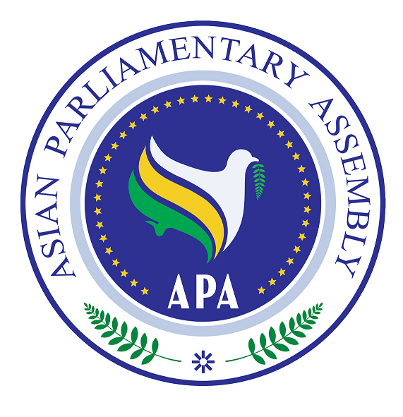

Asian Parliamentary Assembly (APA)

The Secretary General Report on

Environmental Issues,

Global Warming, Climate Change and

Planting Billions of Trees throughout Asia

SG/Rep/2009/07
3 June 2009

Background

The first meeting of the Sub-Committee on Environmental Issues, Global Warming, Climate Change and Planting Billions of Trees throughout Asia was held in Damascus, Syrian Arab Republic, on 21-22 July 2008 and adopted its report, to be submitted to the APA Executive Council and later to the APA Plenary.

The Third Session of the APA Plenary in paragraph 9 of its Resolution on Environmental Issues, Global Warming, Climate Change and Planting Billions of Trees throughout Asia, contained in document APA/Res/2008/03 of 29 November 2008, requested the Secretary-General to seek the views of Member Parliaments on the implementation of the above-mentioned resolution and report thereon to the next session of the Sub-Committee, to be held in the Republic of Korea in 2009 as proposed by the Korean Parliament. Furthermore, in operative paragraph 6 of the said resolution it was decided to designate 'Global Warming and Climate Change' as the theme for further discussions in the next session of the Sub-Committee.

On 19 March 2009, the Republic of Korea graciously offered to host the Sub-Committee meeting in Seoul on 1-2 July 2009. The same day, the Secretary-General communicated with all Member Parliaments and sought their views and those of their governments on the implementation of the Jakarta resolution on Environmental Issues, Global Warming, Climate Change and Planting Billions of Trees throughout Asia.

The present report of the Secretary-General is submitted to the Sub-Committee for its consideration.

Introduction

The Secretary-General's report to the Third Plenary Session contained different elements on the role of Asian Parliaments in addressing the issue of global warming and climate change. Moreover, during the Sub-Committee meeting in Damascus, valuable feedback on the subject of global warming and climate change was received from the participants- as reflected in the report of the Sub-Committee. The Secretary-General considers his last report as well as the last year's Sub-Committee report on climate change still relevant. Therefore, the Sub-Committee may continue its discussions on this issue in its meeting in Seoul. Furthermore, the Sub-Committee may also consider and adopt the following measures.

Strategy on Climate Change

Climate change must become an important factor in all policy areas for Asian countries. In order to deal with global warming and climate change effectively, it is necessary to come up with a strategy on climate change at the national level with the ultimate goal of achieving an Asian Strategy for Climate Change.

In this regard, it is suggested to adopt measures in the following major areas where the Asian parliaments can play a significant role in preparing a strategy on climate change and its proper implementation:

- Greenhouse gas reduction. Legally binding emission reduction targets by 2020 and 2050 can be set. Other measures include placing tax on CO2 emissions and carbon import tax.
- Energy policy. This includes sustainable use of biofuels, yearly energy savings, promotion of energy from renewable sources and improving energy efficiency.
- Other areas. Actions need to be taken in areas such as transport, industry, agriculture, forests, education and population control.
- Technology transfer mechanism and financing clean technology. Proper mechanisms should be devised to facilitate transfer and finance clean technology from industrialized world to developing countries to combat global warming. Furthermore, an international fund is needed to help less developed countries to cope with the negative impacts of global warming such as floods, droughts, and wildfire.
- Role of NGOs and civil society. Efforts should be made, including by parliaments, to promote engagement of NGOs and the civil society in combating global warming.
- The role of private sector (business community). While governments and NGOs are active in dealing with climate change, the private sector (business community) is far behind in this common endeavor. In any strategy for climate change, the private sector should be encouraged to come forward and play its part in the fight against global warming.
- Allocation of budget. Governments and the parliaments should place special emphasis, in the annual budget, on dealing with environmental problems including the global warming.
- Oversight. Specific mechanisms should be designed to oversee and review the implementation of the strategy. Besides governments' own oversight mechanism, parliaments can hold hearings and invite specialists to review the implementation of the strategy.
- Cooperating with UN. The main UN body dealing with climate change is the United Nations Framework Convention on Climate Change (UNFCCC). The current UN/UNFCCC climate change negotiations include four pillars, namely, mitigation, adaptation, technology transfer and finances. Furthermore, the United Nations Environment Programme (UNEP) deals also with the issue of climate change. It is essential that the Asian parliaments ensure that a strategy on climate change is designed in line with the UNFCCC and UNEP recommendations.

Post-Kyoto Regime

The fourteenth session of the Parties (COP14) of the United Nations Framework Convention on Climate Change (UNFCCC) will take place from 7 to 18 December 2009 in Copenhagen, Denmark, The Conference is slated to come to an agreement on the on-going climate negotiations on post-2012 framework and replace the Kyoto Protocol. As part of the preparatory process for the Copenhagen meeting, the last round of climate negotiations will be held in Bangkok, Thailand, from 28 September to 9 October 2009. It will be extremely important for the Asian countries to coordinate their positions during these meetings, especially the Bangkok meeting. The presence of Asian parliamentarians in the national delegations participating in these meetings will enhance the role of Asian parliaments in this important process. Furthermore, in order to become more familiarized with the latest developments on the climate negotiations, the Asian parliaments may hold hearings, with the participation of governmental and non-governmental experts, on the post-Kyoto regime before the Copenhagen conference.

Information Sharing

Better access to and sharing of information and experiences related to climate change will better equip Member Parliaments to address the consequences of global warming. Therefore, as noted in operative paragraph 16 of the APA resolution (APA/Res/2008/03), Member Parliaments are requested to provide data on issues related to climate change and global warming to the Secretariat to be compiled in a database for the reference and use by all Member Parliaments.

Communication with UNEP

On 14 July 2008, the Secretary-General wrote a letter to the Executive-Director of UNEP seeking his advice as to how the Asian Parliaments can better promote mass tree-planting in Asia and oversee, more efficiently, the activities of governments in this regard. On 25 July 2008, the Secretary-General received a letter from the Executive-Director of UNEP inviting APA to be an official partner to the Billion Tree Campaign Initiative. He also underlined that UNEP highly welcomes the active involvement of Asian States to this unique global tree planting project. The Secretary-General distributed the Executive-Director's letter to all Member Parliaments encouraging them to cooperate with UNEP and utilize all its capacities in this regard.

The Way Forward

In addition to the suggestions made by the Secretary-General in his last report, the Sub-Committee may consider, discuss and decide on the following points:

- The APA may urge Member Parliaments to call upon their respective governments to adopt, in line with the UNFCCC and UNEP recommendations, a strategy on climate change. In this context, it may endorse the following measures to be adopted by the parliaments:

  - Adopting a resolution on legally binding emission reduction targets by 2020 and 2050.
  - Placing tax on CO2 emissions and carbon import tax.
  - Adopting an energy policy including sustainable use of biofuels, determining yearly energy savings, promotion of energy from renewable sources and improving energy efficiency.
  - Devising a proper mechanism for technology transfer and financing clean technology from industrialized world to developing countries to combat global warming.
  - Promoting the role of NGOs and civil society in any strategy to combat global warming including holding hearings with the participation of NGOs and civil society on issues related to climate change.
  - Encouraging the private sector (business community) to come forward and play its part in the fight against global warming.
  - Devoting special attention, in the annual budget, to tackle environmental problems including global warming.
  - Designing a specific mechanism to oversee and review the implementation of the strategy on climate change including holding hearings and inviting specialists to review the implementation of the strategy.
  - Encouraging their respective governments to cooperate with UNFCCC and UNEP on activities related to climate change.

- The APA may decide to establish a working group/ advisory group, within the Sub-Committee on Environment, to work on a common legislation on an Asian Strategy for Climate Change.

- The APA may encourage participation of Asian parliamentarians in the national delegations participating in the climate change negotiations to replace the Kyoto Protocol in 2009. It may also encourage the Asian parliaments to hold hearings, with the participation of governmental and non-governmental experts, on the post-Kyoto regime before the Copenhagen meeting.

- The APA may call on Member Parliaments to provide, on a voluntary basis, the data concerning issues related to climate change and global warming to the Secretariat to be compiled in a database for the reference and use by all Member Parliaments.

